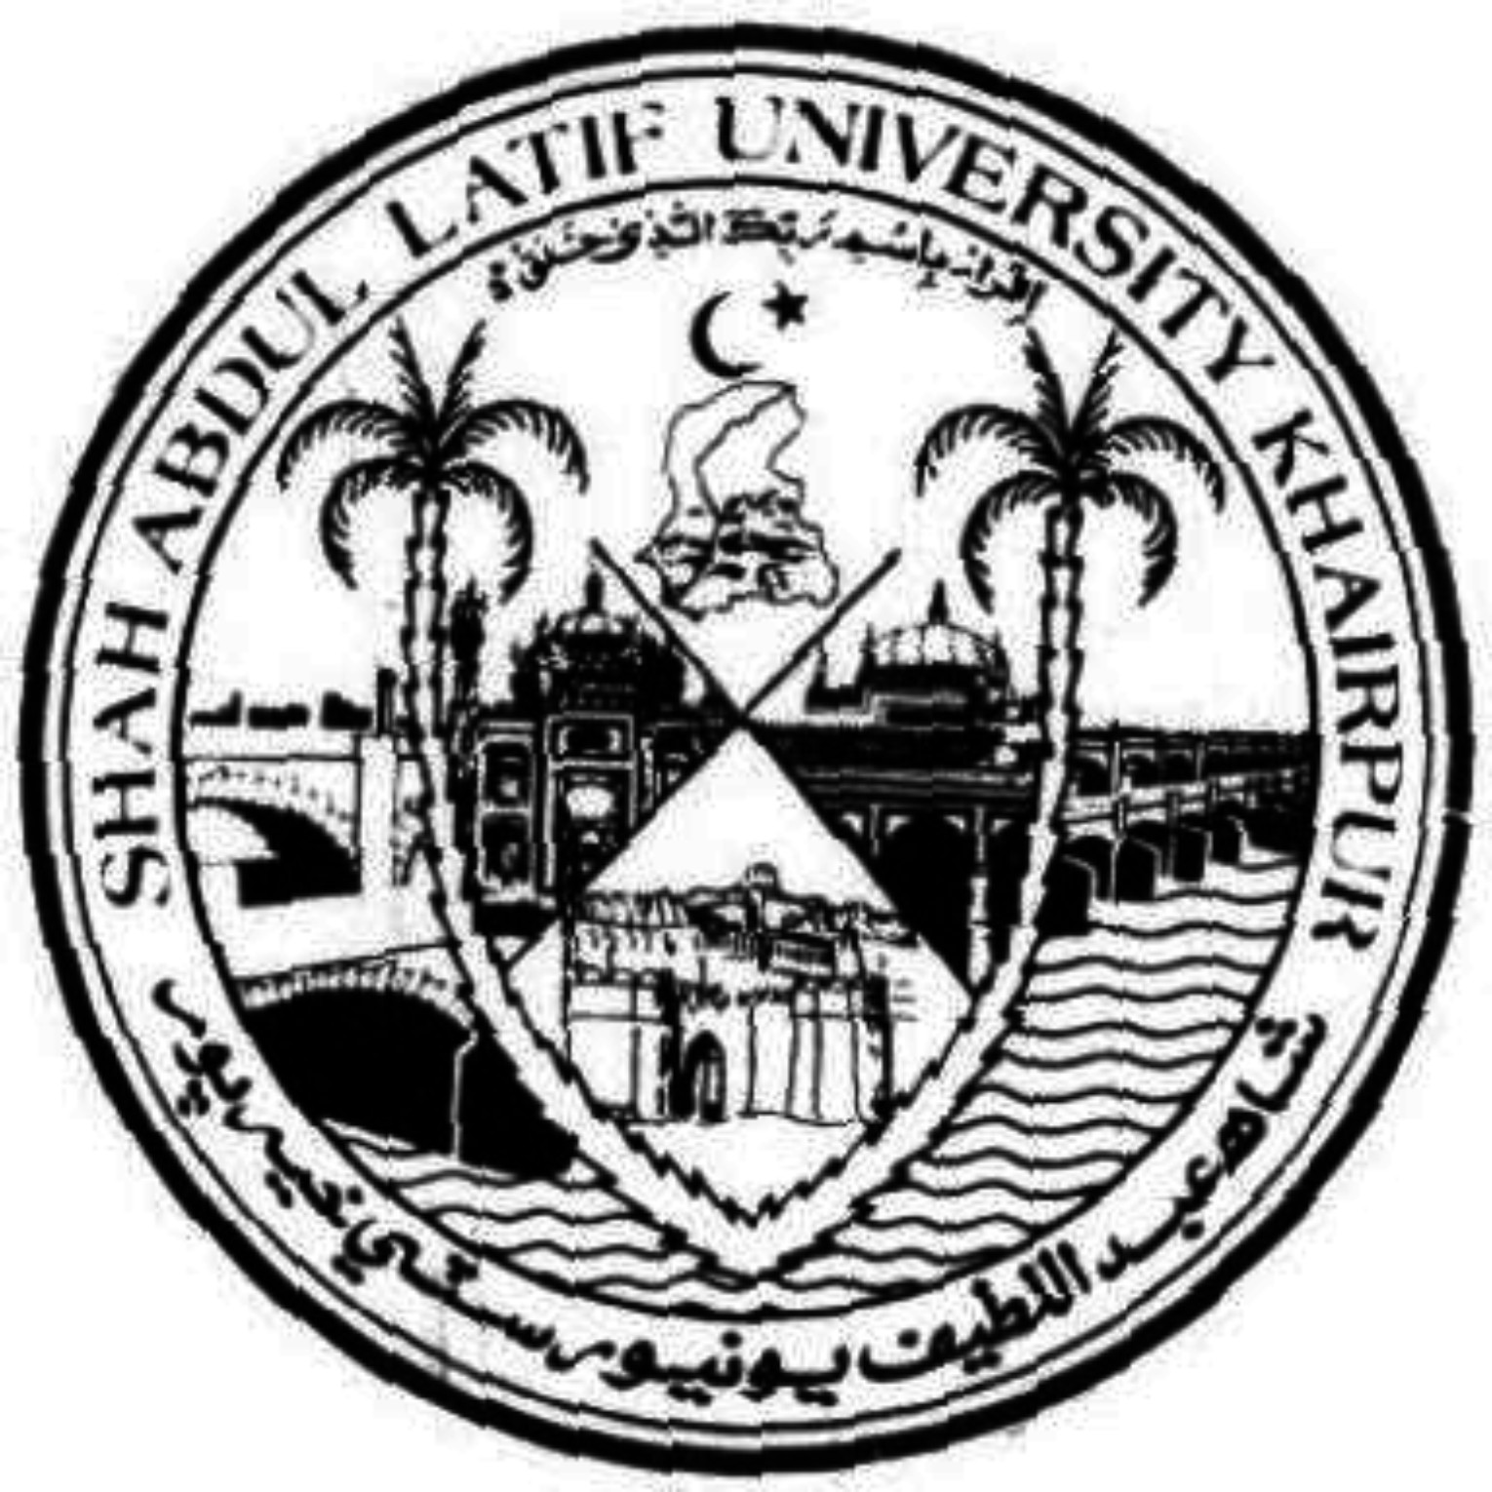
بیان الحکمہ ]تحقیقی مجلہ[
(2017 ء) 01-10

• Dr. Karam Hussain Wadho

The Importance of Emerging Sciences & Technology in The Light of Qur'an & Prophetic Teachings

ABSTRACT: Science and technology is on top position contemporary now it is need of our masses to compare these formulas with holy Quran because Quran is miracle and implementable till the day of Judge ment lot of scientists have benefited by Quran and they also agree up on the excellence of Quran. Hence in this research we have to prove dominancy of Quran over on the science and technology the hints of new inventions and discoveries are available in Quran if we study the Quran deeply we will find in it complete agreement with modern science however it was revealed in that time people were not aware from scientific inventions and they have not know-how of it. Comparatively this time is well advanced period and lot of things invented while concept of these things was present in this sky book I have drawn intention of readers on these points. In this research I would discussed that importance of science and technology specially the sub subjects of the modern science math and statistics geology, astronomy, space sciences, Embryology, Genetics and computer technology. It should be remember that the exposition of this book is also two types scientifically and logically because Quran invites us towards intelligence and wisdom. It is responsibility of scholars to interpret the Quran contemporary because this is not merely ancient book but it is for all times and not for Arabs but for guide line of whole humanity of entire universe. It is challenges itself that no any kind of error or mistake in it foes of Islam tried to find faults but they not succeeded to do so resulting they affirmed dignity of it over on all the books.

Keywords: Science, Obligation, hereafter, Prophet

• Associate Prof:/ Additional Director Directorate of College Educational Regional Directorate of Colleges Larkana, Sindh .

Introduction

Rising science & engineering in the light of Quran the most critical of this is the bewildering advancement of science & innovation yet the essential Question is concerning whether the level of human morals has enhanced at standard with this quick advancement of discernment or not. This is maybe the most essential qualification between the peculiarities of Quran and the period of rise of the science and innovation might advance along corner educated sciences. As the matter of truth Quran enhances human morals alongside science and engineering thusly clearing for the assertion of worldwide Islamic standard.

There are number of Prophetic platitudes that obviously demonstrated the acumen achieves flawlessness of person as could reasonably be expected, for instance drinking water as per prophetic convention is better for you while sitting in Night and remaining in standing the restorative science is likewise demand us to take after this point and receiving this way is valuable for individual in light of the fact that in day we are excursion oxygen gas and engrossing carbon di oxide while in night is equivalent word of it. The Global Islamic guideline might include such peculiarities as the development of advancement of science & innovation

A widespread Islamic govern and is in genuine clash with it, would be conceivable to use its innovative perspective as an effective means for extending Islamic considerations and clearing the way for the universalization of the philosophy of Quran Regarding the science & innovation we can say in this respect we have discarded the educating of Islam and tail others colloquialisms while other are creating their myths and theory.

Islamic point of view the improvement of scientific knowledge is possible it is historical fact that when Yuri Gagarin of Russia arrived at space in 1962 it was asked from Him what are you feeling there his words are still recorded that he said I am under dream are Magic when we recite the Quran in which almighty Allah has said ; "And even if we open to them a gateway of heaven, so that they ascend in to it all the while, they would certainly say only our eyes have been covered over, rather we are enchanted people."(6)

When we say Islam is finished code of life too Holy Quran says "not dry or tree grown foods however all are in clear book"(7)

Implies all the subject of characteristic science is show in Quran yet it is our lack of awareness that we are uninformed from them.

When we contemplate the Quran we will discover in it therapeutic science, space science, embryology, math, data innovation and all the subjects of common and social sciences

In the Quran and Prophets Teachings it has rehashed been underlined that being people we need to thoroughly consider, think about and make perceptions and pursuit in appreciation of manifestations of universe and other living and nonliving things.

That keeping in the perspective of above teachings it has attempted to experience the essential stages on the premise of exploration and encounters as such it is hitter to say that the main wellspring of existing science and engineering is Holy Quran and the teachings of Muhammad (s.w)

In the related concerned exploration Article it has been attempted to assess the production of universe and other living things and will additionally be attempted to demonstrate that how for the current science and engineering have taken after the teachings of sacred Quran .

Case in point the philosophy of running earth was created hundred years after disclosure of Quran while Quran has said "and you see the mountains, you think them to be robust, and they should pass away as the death of the cloud . (8.a)

In other spot Almighty Allah has said with respect to the Boat of Hazrat Nooh "and it proceeded onward with them in the midst of waves like mountains” (8.b)

What’s more designated an earth like support too mountains have been known as the projections that "Have we not made the earth an even breadth? What are more the mountains as a projection (subsequently) (8.c?)

This is intriguing point through this we can educate all the individuals to be mined full from the maxims of Holy Prophet why he said "look for the learning from support to grave and this is required for all the Muslims also look for it even you may go the china" these expression are given much significance to the looking for a lot of information.

That prophet has attempted to upgrade mental methodology of Arabs yet numerous were incapable the contemplating his profitable directions, Quran elucidates their lack of awareness as under "and there are those of them who try to hear you out until when they go forward from you they say to the individuals who have been given the information what was it that he (prophet) said simply now"(9).

Presently developing science and innovation created and ready to develop the new things and also finding of concealed things it is our obligation to get fundamental focuses from Quran in light of the fact that Europe albeit created through illuminate of Quran as now a Muslim researcher has imagined an auto unit through it we can run the auto by water there is no need of petrol or The way that many Muslims have remembered Holy Quran letter by letter, and there are many young men and young ladies of the age of ten and less who have retained the Holy Quran by heart and are called as Hafiz-ul-Quran. Some of them have even had the capacity to remember the majority of the Quran by the age of ten.

As specified in Holy Quran that Allah has taken Himself, the obligation to save and secure the Holy Quran, so hundreds of years passed however nobody can change solitary expressions of it.

The Quran, which was uncovered fourteen centuries prior, specified realities which have just been ran across or demonstrated by researchers as of late. Step by step the science is getting created, the findings and realities are found, the marvels of Holy Quran are acknowledged as these as of late discovered certainties or revelations are as of now specified in the Quran, fourteen hundred years of age uncovered Book. This uproots all the questions about Holy Quran to be the be the strict expressions of God, uncovered by Him to the Prophet Muhammad, and adulterates the claims that the Quran was wrote by Muhammad or by any viable person.

When it is demonstrated and acknowledged that Holy Quran which was brought by Muhammad, is the Book uncovered by Allah, henceforth Muhammad is genuinely a prophet sent by Allah.

It is counter-intuitive that anybody fourteen hundred years back would have known these actualities found or demonstrated just as of late with cutting edge supplies and complex investigative met



“We made the sky a preserved and protected roof yet still they turn away from our signs….” ⁽¹⁰⁾

Science: This aspect of the sky has been proved by the scientific research done in the 20th century that Atmosphere filters the harmful light rays coming from the space and lets only harmless and useful rays such as X-Rays, Ultraviolet Rays, near Ultraviolet Rays, Visible Infrared and Radio Rays. All of these radiations are vital for life such as photosynthesis of plants and survival of all living beings.

The atmosphere also protects the earth from the freezing cold of the space which is about minus two hundred seventy degree centigrade (-270°C) ⁽¹¹⁾

Van allen belt layer/sky: The Van Allen radiation belts are centered along the earth's magnetic equator in a region of the upper atmosphere called the magnetosphere, or exosphere. This layer contains the Ionosphere. The layer caused by the magnetic field of the earth also serves as a shield against the harmful and deadly radiation which is constantly emitted by the sun and the other stars. So this layer of atmosphere / this sky does not allow the solar flares coming from the sun to reach earth. The energy transmitted in just one of these flares/flashes is calculated equivalent to 100 Billion Atomic Bombs similar to one dropped on Hiroshima.

58 hours after the flash it was observed that the magnetic needles of compass displayed an unusual movement and 250kms above the earth’s atmosphere the temperature suddenly reached to 2500°Celsius
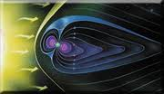
It was Allah, Who could mention such farthest and the deepest facts to be discovered after hundreds of the years. So the Prophet Hazrat Muhammad s.a.w.w who was ummi (who didn’t learn to read and write from anyone), how could he come to know such deeply scientific information which could only be explored, calculated and collected in the 20th or 21st century with the help of highly sophisticated technological machines and equipment.
This reality compels a believer or a nonbeliever to accept that Islam is the religion of Allah and Holy Quran is the Book of Allah and Holy Prophet Hazrat Muhammad s.a.w.w is the last and true Prophet of Allah. Quran is fully of miracles for example we say that the month of year are 12 the word month is used in Quran twelve times and there are 365 days in years and word day is used 365 times it shows the accounting this book is accurate
The concept of creation of universe in six days because total seven days are in week and seventh day is Friday that is called day of judgment it is also quite clear from the opinion of Quran that earth has been created in two days and between earth and heaven in other two days while heavens have been created in two days total of days are six why sky has been decorated with stars the cause of that is mention in this chapter of Quran as under "then seven heaven has been created in two days and he revealed on all skies His order and we have decorated this sky of world with lamps and preserved ” (12)
In addition it is to say that if oxygen gas taken out from the water then we cannot use it this is gesture toward it in surah waqia that “have you considered the water which you drink? Is it you that send it down or we the senders? If we pleased we made it salty why do you not then give thanks."(13)
Do you not see in to water which you are drinking we have bring it from clouds if we make it butter then why you are not thankful to us"
The scientist says “Europe must never target to Quran this is the Quran which enlighten it” even the study of Quran is tedious job for them because they have no any know-how of Arabic syntax in this situation why they are curious because they found in it all scientific subjects the instances of their research and analyzing will be discussed in the research.
When we consider the medical science which recognized a human skin as a prime part of the body all the pains and sorrows are depending on it it the skin is in solace then whole body is in satisfaction this is also stated by Quran that “we shall make them enter fire so oft as their skins are thoroughly burned, we will change them for other skins, that they may taste the chastisement” (14)
At the time of revelation it was not acceptable that the character of human is under record while Quran says "so he who has done an atoms weight of good shall see it, and he who has done an atoms weight of Evil shall see it.”(15)
It shows miracle of Quran that it is possible to record movie and video system and through it we can easily record the characters if creatures can do it then why the creator cannot does it now a days we are seeing others character but on the day hereafter we see our character. there are two kinds of science theoretical and practical theoretical we study in books and practical we can understand after experiment and laboratory are observe in other words each and every thing we can listen which is come in to the ambit of theoretical while all other things which are we studied then prove after experiment and general observation is come in the ambit of practical above mentioned verse is gesturing toward the practical science while now I am quoting here the theoretical science is as under ;
“And the Book shall be placed and you shall see the guilty fearing from what is in it, and they will say; ah! Woe to us! What a Book is this it does not omit a small one nor a great one, but numbers them (all) and what they had done shall find present there."(16)
Prof Cathamore ex-chairman of Embryology department Taranto university Canada when saw a verse of holy Quran regarding three walls becomes Muslim because he has stated in his book “Before we are born” that the medical science was ignorant from this fact before micro scope from these stages in 1945 when we invented it then informed these walls while Quran was well informed from it before 1400 years as Quran says “He creates you in the wombs of your mothers- a creation after a creation- in triple darkness;(17)
As per opinion of Dr Cathmore the embryology only nominated as abdominal wall, uterine wall and am brio chronic membrane while Quran already discovered them while as per my humble opinion these names are not merely told by Embryology Department after invention of Micro scope but when we study the “Dua Arafa” recited by Hazrat Hussain (a.s) Muslims’ Leader and Grandson of our Holy Prophet (s.w) refer same piece as under in which he tells the names of above three dark-nesses “so oh; Almighty Allah you fashioned my creation from semen that gushed forth and put me up in triple darkness among flesh, blood and skin”(18)
The German scientist when saw the kalma on the breath lungs to evaluate the human body on computer then he accepts Islam Then he becomes Muslim. Same picture also published by famous magazine refer (19) this is also recognition of verse of holy Quran in which it appears that “we will soon show them our signs in the universe in their own souls, until it will become quite clear to them that it is the truth” (20) Contemporary man is curious to tress the new things and deemed them on appropriate positions for his benefit and ease as well as solace and satisfaction.
The destroying of world trade Centre which consist 109 &110 stages event was held in ninth month 11th date that was largest buildings of the world when we study the ninth surah of Quran Repentance in which 11th part and verses numbers also same i.e. 109&110 with similarly describes as follow “Is he therefore, batter who lays his foundation on fear of Allah and (His) good pleasure, or he who lays his foundation on the edge of the cracking hollowed bank, so it broke down with him into the fire of hell; and Allah does not guide the Unjust People.” In other ayah 110 it is clear as under that “the building which they have built will ever continue to be a source of disquiet in their hearts except that their hearts get cut in to the pieces ;”( 21)
The discovery of fighter aero plane as in the war of zatusalasul prophet (p.u.h)sent a troop under the commanding of Hazrat Ali karamullah wajhahu to attach on unbelievers at dawn time no doubt that time horse was running rapidly but this time fighter aero plane are fast due to that the surah was revealed about them the Assaulters (Adiyat) in which Almighty Allah has said “I Swear by the runners breathing pan tingly, then those that produce fire striking, then those they make raids at morn, thereby raise dust, then rush thereby upon an assembly;” (22)
Now you can see when Airplane flying breathing pan tingly and fire striking from their feet and mostly fighter Airplane attacking dawn time because this time radar is not functioning properly and unable to see the airline of attackers.
It is for the information of all Muslims that we have omitted the Teaching of Islam and Quran as well otherwise no any hidden knowledge which is not in Quran as stated that "neither hidden thing in skies nor in earth but all is in manifest Book'(23)'
It is quite clear that why we backward in the sphere of science and technology because we ourselves try to understand Quran while another Book of any subject of science we not cannot understand without any teacher and scientist hence it is our responsibility to search the real interpreter of Quran.
And Almighty Allah has said in Quran that "the witness of Apostle among the unbelievers is Allah and who has plenty of knowledge of Book (Quran)"(24)
It is mentioned in lot of Muslims books that the knower of Book in batter manner is Hazrat Ali(a.s) at least 13 narration quoted by Sheikh Sulaman Balakhy Qandozi that above verse is in the favour of Hazrat Ali (karamullah wajhahu)(25)
In view of these narrations we can say that after Holy Prophet (s.a.w) he guided to Muslims towards the wisdom and technology due to that he said 'if I want to tell you the formula through the waterfall you receive the light this formula is adopted by some scientists for formulation and making the electricity.

Results
It is a great miracle that these facts, which could not possibly be discovered without the technology of the 20th century, were explicitly stated by the Qur'an 1,400 years ago.
That is the reason that Islam is fastest growing religion of the world as given above statement with the references.
1400 years ago no one could even think about the technological development which is available nowadays.
Hence it is also considered as proof of the truthfulness of Islam and Quran is the book of Allah the Almighty, the Creator and the Sustainer of the Universe.

Discussion
I think this will be proven more beneficial not only for our country but whole Muslim Umah for uplift and flourishing of their scientific know-how towards Quran and Prophetic teachings regarding the matter.
The dignity of Quran is unanimously accepted between Muslims and Non-Muslims it could not be denied and this book is implementable till day of Judgmental.

Conclusion
Quran is consist all types of knowledge and education for understanding this Book properly we have to follow those whom knowledge is flourish and they are absolutely spotless personalities house holders of Holy prophet they have said door of knowledge as well as inhere ter of Book .
These are those prophet had introduced them in his last time of his life in this connection the narration of Jabir s/o Abdullah ansari and sulaim s/o Qais are sufficient for us in different times these narrations have been quoted from Innocent leaders among them last is Mahdi (a.f.s)

References

1. Quran: 5/59
2. Quran: 4/113
3. Quran: 16/125
4. Quran: 2/269
5. Quran: 4/113
6. Quran: 15/14-15
7. Quran: 6/59
8. Quran: 27/88
9. Quran: 47/9
10. Quran: 21/32
11. Quran: 2/29
12. Quran: 41/12
13. Quran: 56/68-69
- Quran: 4/56
- Quran: 99/7 & 8
- Quran:18/49
17. Quran: 39/6
- Muhammad Raza Marchant, “zad rah with manasik haj” (Karachi: published by zadrah trust) P,273
- Muhammad Hussain Masoodi “Alharman”Magazine,(Karachi:Alather publication Nazimabad) P,27
- Quran: 41/53
- Quran: 9/110
- Quran: 100: 1 to 5
- Quran: 27/75
- Quran: 13/43
- Sheikh Suleiman Balky Hanafi( Yanabeal mawadat) (Lahore: General book Agency Ansar Press, year 1963) P,168

